

Draw It or Lose It

# **CS 230 Project Software Design Template**

Version 1.0

## Table of Contents

**CS 230 Project Software Design Template**1

**Table of Contents**2

**Document Revision History**2

**Executive Summary**3

**Design Constraints**3

**System Architecture View**3

**Domain Model**3

**Evaluation**3

**Recommendations**5

## Document Revision History

| Version | Date | Author | Comments |
| --- | --- | --- | --- |
| 1.0 | <mm/dd/yy> | <Your-Name> | Design, domain and executive summary information provided |

**Instructions**

Fill in all bracketed information on page one (the cover page), in the Document Revision History table, and below each header. Under each header, remove the bracketed prompt and write your own paragraph response covering the indicated information.

## Executive Summary

The game Draw It or Lose It needs help in being turned into a web-based application. The Gaming Room is our new client for this project. Our primary goals are to help setup the game to have one or more teams which will be assigned multiple players. All names must be unique within the game.

## Design Constraints

Staying within our time frame and budget is going to be the biggest constraint. A profitable application in a reasonable amount of time is what the client expects. We must present the application in a manner that is consistent with the vision of The Gaming Room. We need to test the software and implement feedback from the client and testers for user experience.

## System Architecture View

Please note: There is nothing required here for these projects, but this section serves as a reminder that describing the system and subsystem architecture present in the application, including physical components or tiers, may be required for other projects. A logical topology of the communication and storage aspects is also necessary to understand the overall architecture and should be provided.

## Domain Model

We will be using seven classes to implement the design in a way that we want them. The parent class will provide the base variables of Id and name for its child classes. These variables will need to have the base getters for Id and name which will be inherited by the child classes of Player, Game and Team. Game class will create a list for all the teams that are created as well as the methods to add a team name to the list. Active players list will be under the team class and will be a method to add new players to the list. Within the player class this will provide the means of creating a player instance. Using a singleton pattern, the GameService Class will interact with the four other classes. Iterator patterns will be used within GameService so the application can efficiently iterate through all the names to make only one active instance. Driving the application will be the ProgramDriver class.

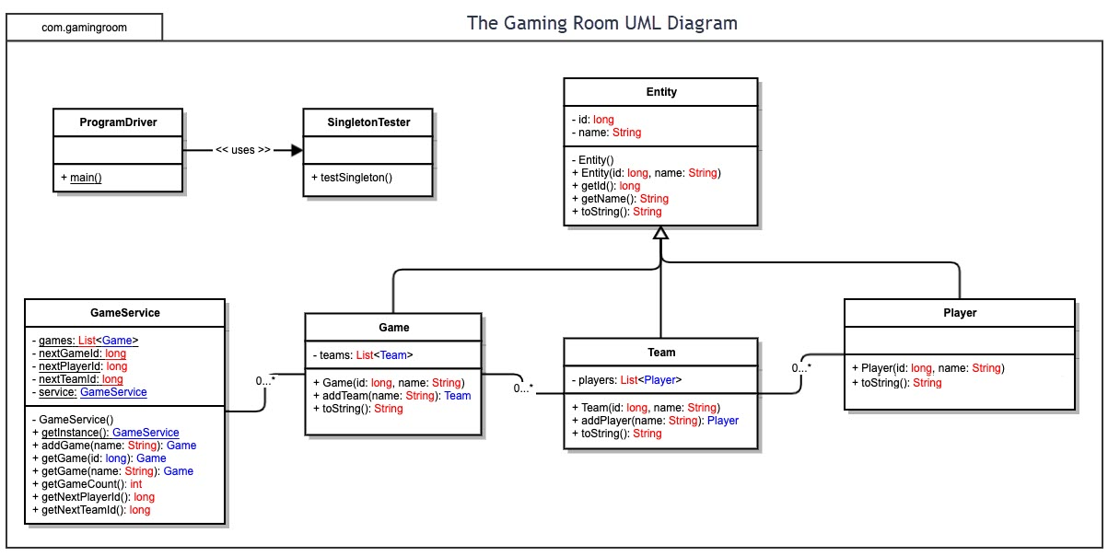

## Evaluation

Using your experience to evaluate the characteristics, advantages, and weaknesses of each operating platform (Linux, Mac, and Windows) as well as mobile devices, consider the requirements outlined below and articulate your findings for each. As you complete the table, keep in mind your client’s requirements, and look at the situation holistically, as it all must work together.

In each cell, remove the bracketed prompt and write your own paragraph response covering the indicated information.

| **Development Requirements** | **Mac** | **Linux** | **Windows** | **Mobile Devices** |
| --- | --- | --- | --- | --- |
| **Server Side** | Allows for an easy creation of features comparable to Win group policies.  Disadvantages: Has hardware limitations. Some productivity software is unavailable on mac | Linux is Unix-based and was designed to provide an environment that is powerful, stable and reliable but easy to use. Linux systems are known for their stability and reliability. | Windows hosting is a web hosting that locates user file on a server that uses the operating system. It supports hypertext language files. There are two options when it comes to web hosting- Linux and Windows. Linux is better on the hosting side; windows is gaining popularity and it is becoming the one most commonly used. | The hardest option is for you to code your entire backend yourself and find a provider that will host your mobile app. This option needs a variety of skills. If you need a wide choice of customization and have the required expertise in your team, you can consider it |
| **Client Side** | Mac cost more than windows and this means the user is forced to buy from apple. | Linux is widely considered one of the best operating systems around. This is true for software programmers.  Since you don't have any financial upfront costs, the only cost to you is gaining an understanding of it.  Most of the software for it is also open source, which is nice. | It is a good platform for **developing** web sites and native **windows** apps. A **good** option is to bootcamp a Mac and run **windows** as your OS. But then boot to Mac OS to do the apple stuff. | phones and tablets are the two mobile devices with a few crossover devices in between. Phones have limited screen space. Mobile platform UI controls have been designed specifically to be effective on smaller form factors. |
| **Development Tools** | C is the most common language used in Mac | Linux has good support for programming languages.  Linux supports all languages. | **C++** is the language at Microsoft, which uses **C++** to build applications. **C++** is general-purpose programming language. **C++** is used in the software industry, and is the leading language. | Swiftic is one of the top mobile app development frameworks available in iOS  Java is the main language for Android App Development and it is the most used language. |

## Recommendations

Analyze the characteristics of and techniques specific to various systems architectures and make a recommendation to The Gaming Room. Specifically, address the following:

**Operating Platform**: PC and mobile games have differences in the way they are used, operated, main play and how the game in general works. All games on PC and mobile have their own characteristic which can have benefits. All games platforms develop games that are most qualified to be on the platform. Those games will determine the quality of the platforms, so that the game developers can develop a game with maximum benefit. Personally, I recommend windows because of all this.

**Operating Systems Architectures**:

Arm: Is not powerful compared to x86 and has limitation maximum possibility on arm arch is mobile gaming.

X86: Powerful and huge development so it’s easy to develop a game on a platform like unity, huge hardware compatibility and support

**Storage Management**: For storage we have few choices where HDD is slow and old, new consoles use SSD

I recommend SSD.

SSD has options like SATA and NVME

NVME SSD is my recommendation

**Memory Management**: 32-bit windows has its own virtual address space that allows addressing up to 4 gigabytes of memory. Each process on a 64-bit has a virtual address space of 8 terabytes. Threads cannot access memory that belongs to another process, this prevents corruption.

**Distributed Systems and Networks**: Network based interaction systems such as network games include a database shared among the players that are physically distributed and interact with one another. Network game developers must implement the shared database and the inter player communications from nothing. Using a high-level interface this is recommended for online games.

**Security**: There is a risk of data loss or access to your account. When visiting an online casino or gaming on PC and smartphone, you can do a lot to reduce this risk. Security needs to be taken seriously when it comes to accessing anything online which is virtually everything now. With the use of data controls, you can reduce your risk of becoming a victim of unauthorized access to your account.